Friday, December 11 Logistics problems
1) A frozen steak has a temperature of 28°F. It is placed in a room with a constant temperature of 70°F. After 10 minutes, the temperature of the steak has risen to 35°F.
a) What will the temperature of the steak be after 60 minutes?
b) How long will it take for the steak to thaw to a temperature of 45°F?

2) Bacteria growing in a petri dish grow exponentially. After 15 minutes the dish has 200 cells, after 30 minutes the dish has 400 cells. If the dish can only hold 100,000 cells, how many bacteria cells will there be in 2 hours? 3 hours? How long will it take to reach 50,000 cells?

3) A pizza baked at 450°F is removed from the oven at 5pm into a room that is a constant 70°F. After 5 minutes, the pizza is at 300°F.
a) At what time can you begin eating pizza if you want its temperature to be 135°?

4) A soda room temperature at 72°F is placed in a refrigerator where the temperature is a constant 38°F. The soda is 70.4°F after 7 minutes
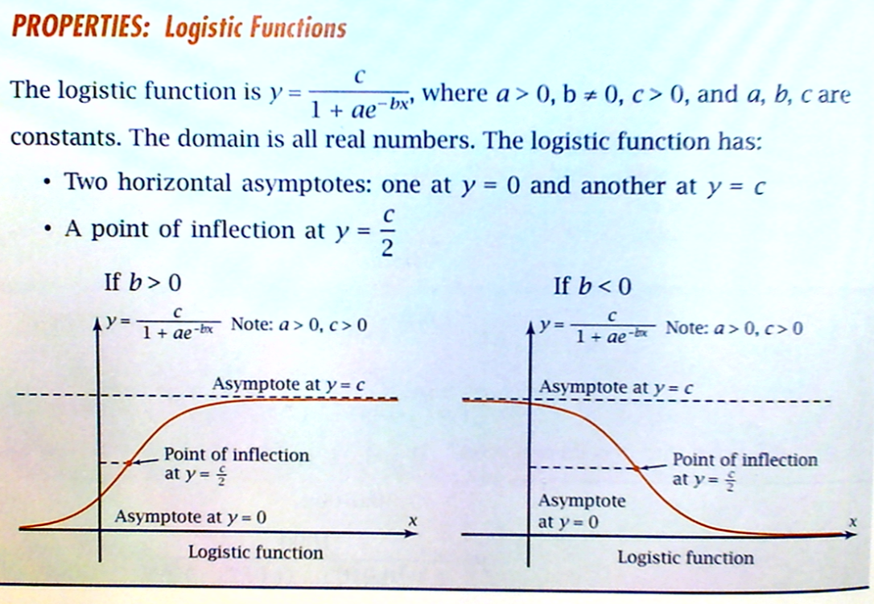
Find the time it will take before the soda is 39°F.

